**Boppudi Vivek(916243)**

**Hnadson Day-1 Session -2**

**1) TypeScript data types and interface – Define Employee interface and display**

**Employee.ts**

**export interface Employee {**

**id:number;**

**name:string;**

**salary:number;**

**permanent:boolean;**

**}**

**Employee-test.ts**

**import { Employee } from './Employee';**

**var emp:Employee = {**

**id:3,**

**name:"John",**

**salary:5000,**

**permanent:true,**

**}**

**console.log("id : "+emp.id);**

**console.log("name : "+emp.name);**

**console.log("salary : "+emp.salary);**

**console.log("permanent : "+emp.permanent);**

**OUTPUT:**

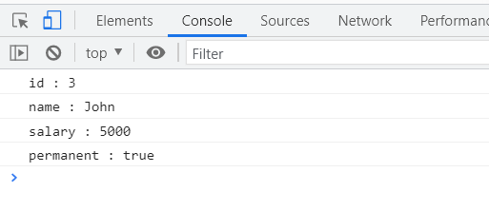

**2) TypeScript data types and interface – Include Department details in Employee and display**

**Department.ts**

**export interface Department{**

**id:number;**

**name:string;**

**}**

**Employee.ts**

**import { Department } from './Department';**

**export class Employee implements Department{**

**id:number;**

**name:string;**

**salary:number;**

**permanent:boolean;**

**constructor(id:number, name:string, salary:number, permanent:boolean){**

**this.id = id;**

**this.name = name;**

**this.salary = salary;**

**this.permanent = permanent;**

**}**

**}**

**Employee-test.ts**

**import { Department } from './Department';**

**import { Employee } from './Employee';**

**var emp1 = new Employee(123, "John", 5000, true);**

**console.log("id: "+emp1.id);**

**console.log("name: "+emp1.name);**

**console.log("salary: "+emp1.salary);**

**console.log("permanent: "+emp1.permanent);**

**var dept:Department = {**

**id:1,**

**name:"Payroll",**

**}**

**console.log("Department id : "+dept.id);**

**console.log("Department name : "+dept.name);**

**OUTPUT:**

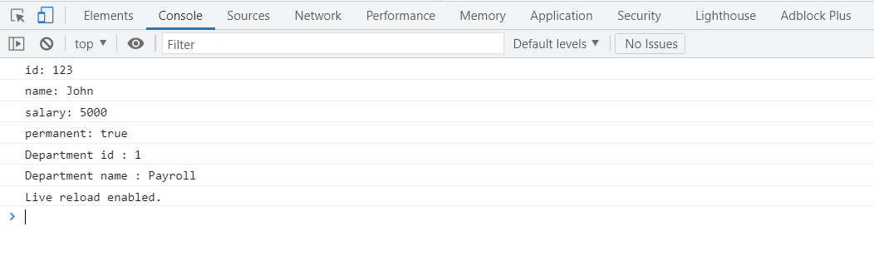

**3) TypeScript data types and interface – Define Employee interface and display**

**Department.ts**

**export interface Department{**

**id:number;**

**name:string;**

**}**

**Skill.ts**

**export interface Skill{**

**id:number;**

**name:string;**

**}**

**Employee.ts**

**import { Employee } from './Employee';**

**import { Skill } from './Skill';**

**import { Department } from './Department';**

**var emp1 = new Employee(123, "John", 10000, true);**

**console.log("id: "+emp1.id);**

**console.log("name: "+emp1.name);**

**console.log("salary: "+emp1.salary);**

**console.log("permanent: "+emp1.permanent);**

**var dept:Department = {**

**id:1,**

**name:"Payroll",**

**}**

**console.log("Department id : "+dept.id);**

**console.log("Department name : "+dept.name);**

**var skill1:Skill = {**

**id:1,**

**name:"HTML",**

**}**

**var skill2:Skill = {**

**id:2,**

**name:"CSS",**

**}**

**var skill3:Skill = {**

**id:3,**

**name:"JavaScript",**

**}**

**console.log("Skill[0]:"+skill1.id+", "+skill1.name);**

**console.log("Skill[1]:"+skill2.id+", "+skill2.name);**

**console.log("Skill[2]:"+skill3.id+", "+skill3.name);**

**Employee-test.ts**

**import { Employee } from './Employee';**

**var emp1 = new Employee(1, "HTML");**

**var emp2 = new Employee(2, "CSS");**

**var emp3 = new Employee(3, "Javascript");**

**console.log("Skill 1: "+emp1.id+", "+emp1.name);**

**console.log("Skill 2: "+emp2.id+", "+emp2.name);**

**console.log("Skill 3: "+emp3.id+", "+emp3.name);**

**OUTPUT:**

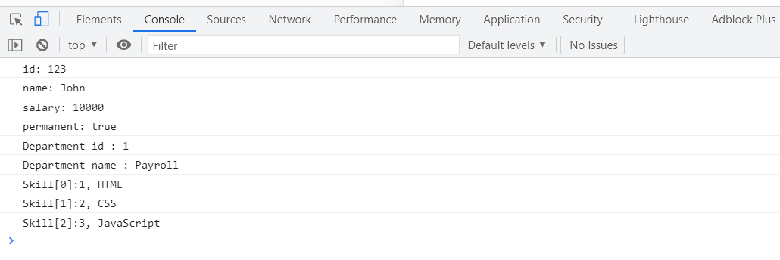

**4)**

**interface User {**

**name: string;**

**id: number;**

**}**

**class UserAccount {**

**name: string;**

**id: number;**

**constructor(name: string, id: number) {**

**this.name = name;**

**this.id = id;**

**}**

**}**

**const user: User = new UserAccount("Murphy", 1);**